SF.SmokeTest_Manager_TC_SF_ManagerLogin_Instance1_12-Apr-2017_09-48-18_AM_Error.png

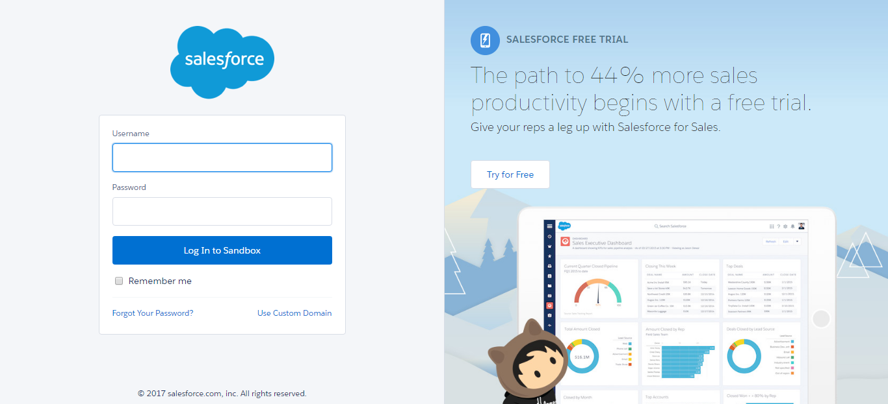

SF.SmokeTest_Manager_TC_SF_ManagerLogin_Instance1_12-Apr-2017_09-48-29_AM_Error.png

